Lab 2 - Outputs

The unsuccessful output
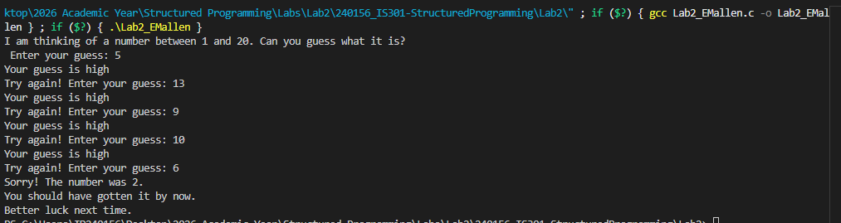
Successful output
